The City of Minneapolis is helping residents save money and increase comfort in their homes. While funds last, the City is offering 0% financing on recommended energy-saving upgrades to all households (no income limit) and free Home Energy Squad visits to households with a family income less than $100,000. All residents living in a Minneapolis Green Zone are eligible for the free energy visit regardless of income: Bottineau, Cedar-Riverside, East Phillips, Hawthorne, Marshall Terrace, McKinley, Midtown Phillips, Near North, Phillips West, Sheridan and Ventura Village.

HOME ENERGY SQUAD

A team of energy experts will come to your home, evaluate your energy saving opportunities and:

* Install energy-saving materials such as: LED light bulbs, door weather stripping, a programmable thermostat, high-efficiency water fixtures, and more
* Perform a blower door test to measure for air leaks
* Complete a visual insulation inspection including infrared imaging when possible
* Safety check your home’s heating system and water heater

0% LOAN PROGRAM

To qualify the borrower must have received a Home Energy Squad visit within the last 3 years.

* 0% APR
* $15,000 maximum loan amount
* Terms up to 7 years
* No closing costs
* Eligible improvements include: attic insulation and air sealing, wall insulation, air source heat pump (for heating, cooling, and water heating), health and safety issues, and solar
* Other qualifying conditions apply

TO APPLY OR LEARN MORE ABOUT 0% FINANCING CALL 612-335-5884 OR

VISIT MNCEE.ORG/MPLS

TO SCHEDULE YOUR HOME ENERGY SQUAD VISIT CALL 651-328-6220

OR VISIT MNCEE.ORG/HES-MPLS

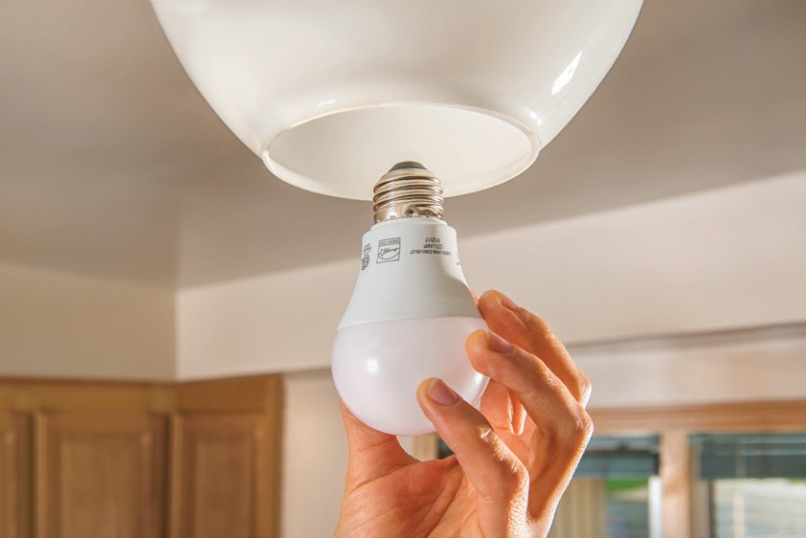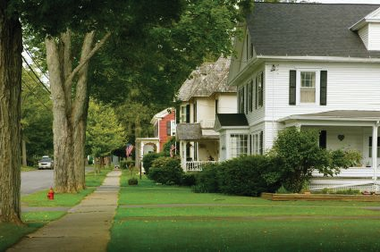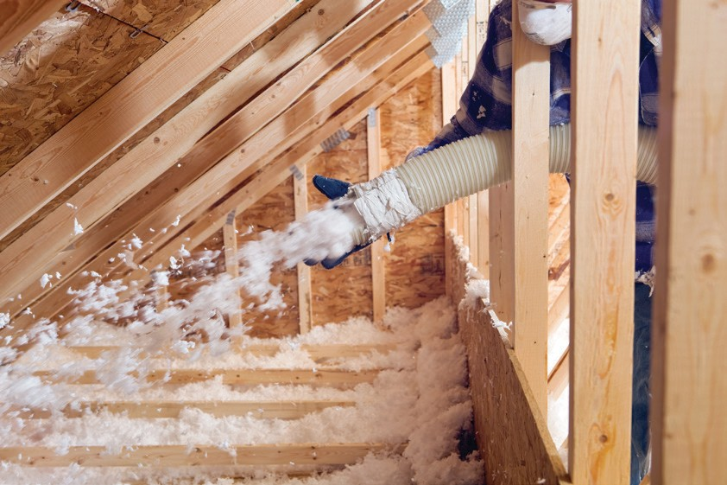

**SAVE ENERGY AND MONEY**

**NO COST FINANCING & FREE ENERGY AUDITS**

*For those not located in a Minneapolis Green Zone listed above or who have a family income above $100,000, Home Energy Squad is available for $100.*

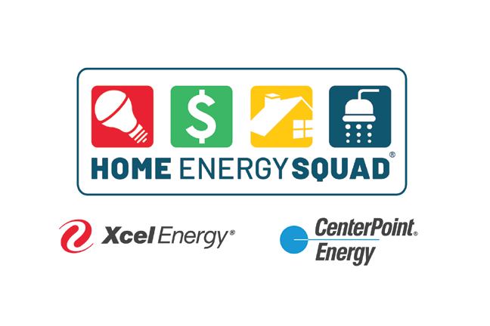

Home Energy Squad is provided by CenterPoint Energy and Xcel Energy, and delivered by the local nonprofit Center for Energy and Environment (CEE). CEE also administers the 0% financing on behalf of the City of Minneapolis.

